**Enhancement Three: Databases**

The artifact selected is the Travlr Getaways Travel Booking Website, developed during the CS465 Full Stack Development course. This project is a comprehensive web application enabling users to browse and book travel packages, complete with features for user authentication, trip management, and booking functionalities.

I chose this artifact for my ePortfolio because it showcases a broad range of skills in full-stack development, particularly in database management, and user interface design. The enhancement focuses on expanding the MongoDB database capabilities to include advanced features such as text indexing, aggregation pipelines, and database transactions. These improvements demonstrate my ability to implement complex database solutions, enhance search functionality, and ensure data integrity – all critical skills in software development.

This enhancement also shows my ability to design and implement database solutions that support complex data operations and ensure consistency and reliability in data handling. Additionally, the enhancements include implementing text indexing and aggregation pipelines in MongoDB to support complex queries and improve search performance. To enhance the search capabilities, I implemented text indexing on the name and description fields of the Trip model. This allowed for efficient text search queries using MongoDB's $text operator. To generate complex queries for analytics, I utilized MongoDB's aggregation framework. For instance, I implemented an aggregation pipeline to calculate the total number of bookings per destination and the average cost of travel packages. To ensure data integrity during booking and cancellation operations, I implemented database transactions. This involved using Mongoose sessions to ensure that all related operations either succeeded or rolled back together.

The enhancement aligns with several course outcomes. Employing strategies for building collaborative environments enables complex data analysis and reporting, supporting better decision-making processes. Designing and evaluating computing solutions are demonstrated through the advanced query capabilities and transactional integrity, which showcase effective problem-solving using algorithmic principles and computer science practices.

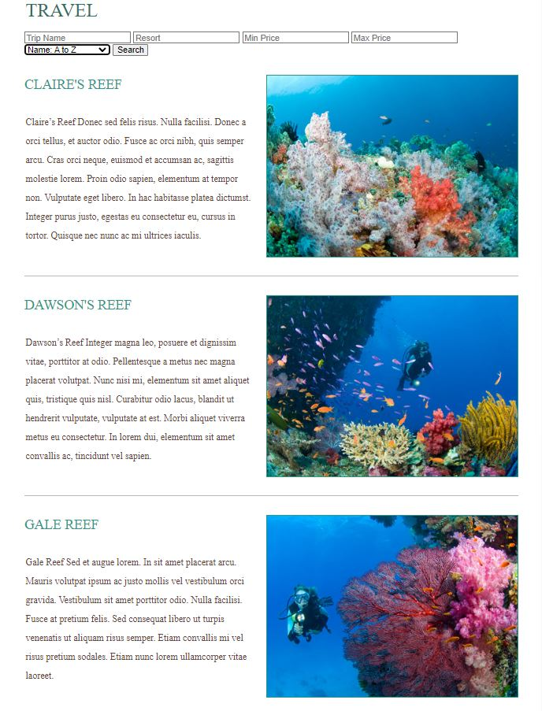Enhancing this artifact required an in-depth understanding of MongoDB's advanced features. I learned to implement text indexing to improve search efficiency and used aggregation pipelines to generate complex queries for analytics. One of the significant challenges was ensuring data integrity during booking transactions. By implementing database transactions, I ensured that all operations related to a booking either completed successfully or rolled back to maintain consistency.

Search/filter test

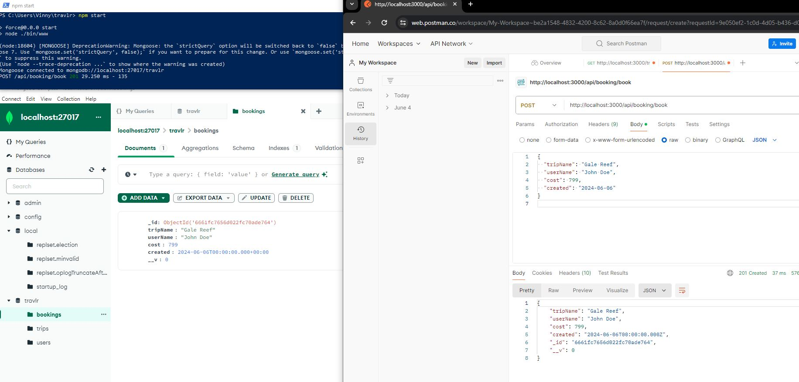

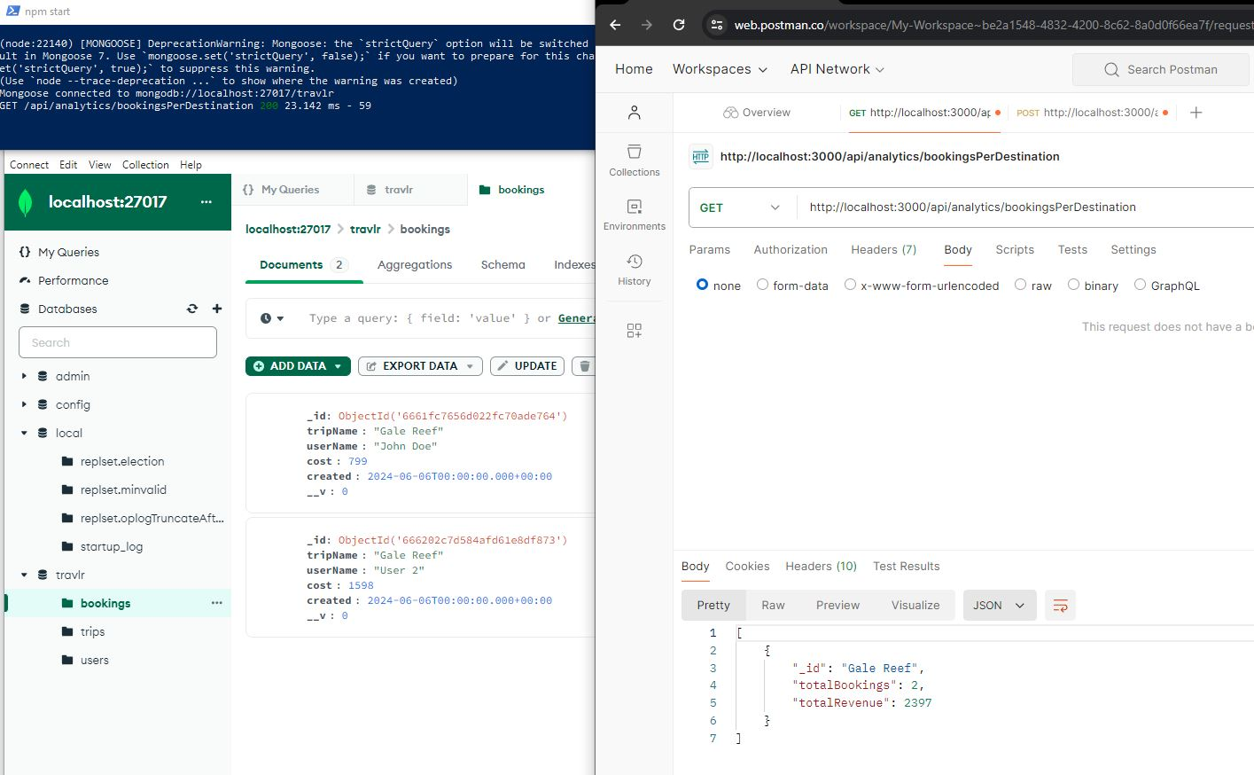Booking post test

Analytics test